Deep Learning-Based Face Detection on Embedded Systems

Donghwa Lee

School of Computer & Communication Engineering, Daegu University
201 Daegudaero, Jillyang, Gyeongsan, Gyeongbuk, 38453 Republic of Korea
leedonghwa@daegu.ac.kr

Abstract
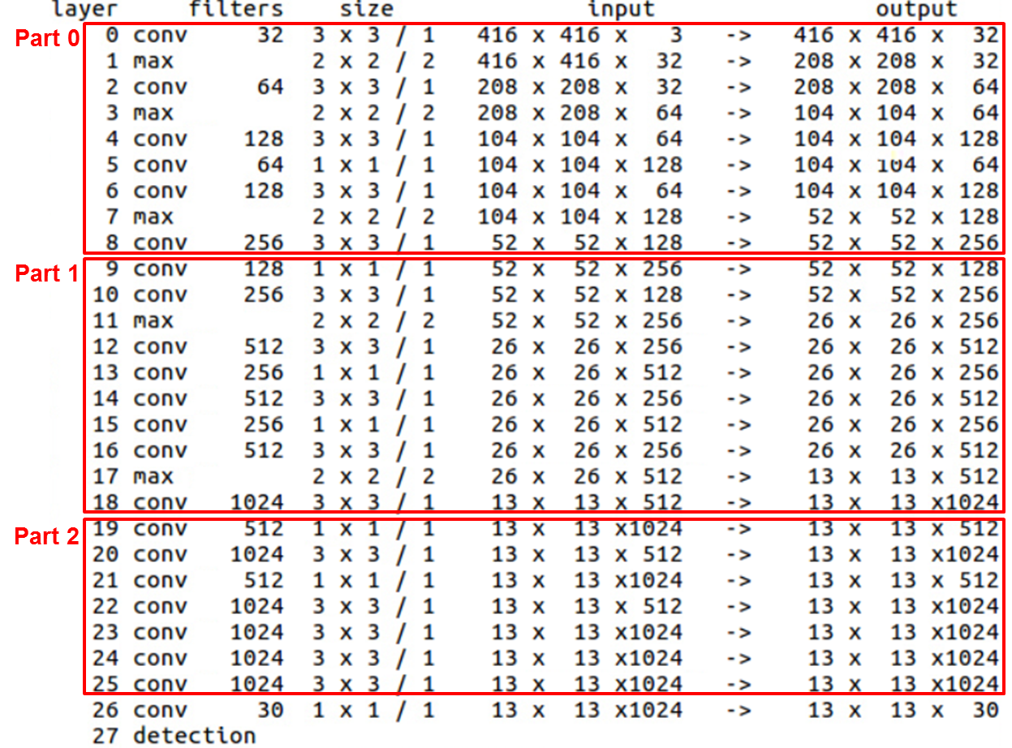
Fig. 1 YOLO algorithm structure for face detection. The structure is divided into three parts for hints training.

In this paper, we implemented deep learning based face recognition system. Recently, many techniques have been developed for detecting objects at specific locations based on deep learning algorithms. Among various deep learning techniques, we choose the YOLO algorithm which shows fast and good performance. In recent research, various attempts have been made to reduce the convolutional structures. These studies in the field of deep learning are called knowledge distillation (KD). Through this study, we discuss a method for applying the KD strategy to face detection on embedded systems.

Keywords: Face Detection, Deep Learning, Convolutional Neural Networks (CNN), Knowledge Distillation (KD)

I. Introduction

Recently, convolutional neural networks (CNN) based deep learning methods have shown good performance in face detection and object recognition domain[1, 2]. In particular, the you only look once (YOLO) algorithm show very good face detection performance[3, 4]. However, it is still difficult to implement the CNN-based deep learning algorithms on embedded systems because of the limitation of the computational speed.
In recent research, various attempts have been made to reduce the computational cost of convolutional layers while maintaining the performance in the deep-learning algorithms[5, 6]. These studies are called knowledge distillation (KD) methods. They try to reduce the amount of computation by eliminating redundant parts of the deep learning structures.
In this paper, we have conducted experiments for face detection based on YOLO algorithm. And we tested the performance of the original YOLO algorithm. Then, we implemented the hints training method, and training the same deep learning structure part by part. Finally, we compared the performance of the learned deel-learning structure with that of the original structure.

II. Proposed Method

The overall structure of the yolo algorithm for face detection is shown in Fig. 1. It consists of convolutional layers of various shapes, and outputs the position of the face in box shape coordinates. Since the object to be detected is one kind (face), the last CNN layer of the YOLO structure has the output of 13×13×30. Although the YOLO algorithm is faster than other deep learning algorithms, it is still difficult to apply it to the embedded system environment.
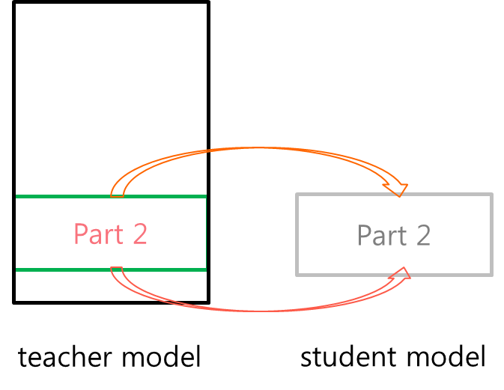
Fig. 2 Hints training on the YOLO algorithm.
Fig. 2 shows the process of applying hints training to the yolo algorithm. After reducing the structure of the convolutional layer, training should be performed for each part in order to obtain the KD effect. First, after dividing the original YOLO structure into three parts. Then, the hints training is performed for each part by using each intermediate inputs and outputs. The structure is trained by applying a linear function instead of a ReLU function to the output activation function of each part.
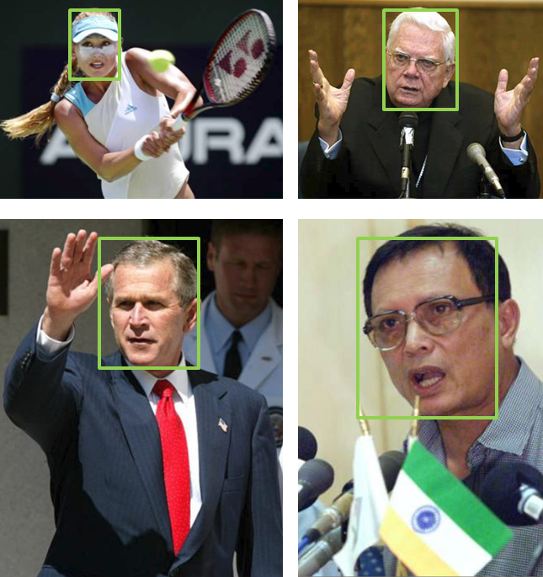

Fig. 3 Face detection data set and benchmark (FDDB). FDDB provides accurate annotations for face detection performance evaluation.

III. Experiments

For the face detection experiment, the face detection data set and benchmark (FDDB) data is used. FDDB provides accurate annotations for face detection performance evaluation. Fig. 3 shows some examples of FDDB datasets. For the experiment, we prepared three models. Of the total FDDB dataset, we used 2,029 images for training and 379 images for testing. The original yolo model was modified by only the last layers and then fine tuned using the weight values trained through the VOC2 data. In the case of hints trained original YOLO model, the yolo structure was divided into three parts and hints training was performed for each part, followed by fine tuning. The tiny-YOLO model is modified in the final stage and fine tuned using existing VOC2 based weights. For each of the three YOLO models, 80,000 iterations are performed for fine-tuning.
The face detection results are shown in Fig. 4 and TABLE I. Hints training is performed well, and performance is better than tiny-yolo. This shows that the reduction of the CNN structure and the hints training can obtain the KD effect.

IV. Conclusion
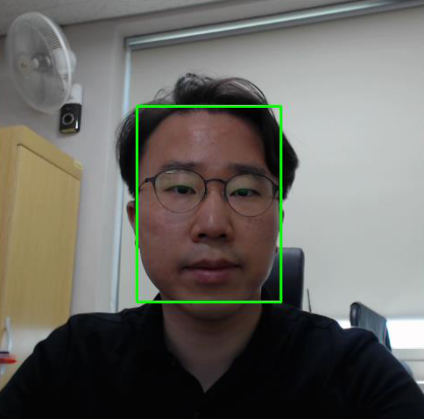

Fig. 4 Face detection result using the hints trained YOLO model and webcam.
In this paper, we implemented deep learning based face recognition system. we have conducted experiments for face detection based on YOLO algorithm. Through this study, we have investigated the applicability of deep learning algorithm to embedded system.

Acknowledgment

This work was supported by the National Research Foundation of Korea(NRF) grant funded by the Korea government (Ministry of Education) (NRF-2016R1D1A1B03934666).

References
TABLE I
FACE DETECTION RESULTS

YOLO Models | Precision | Recall | Average IOU
original YOLO | 89.9 % | 95.9 % | 85.0 %
hints trained original YOLO | 85.2 % | 94.3 % | 83.9 %
tiny-YOLO | 82.7 % | 92.4 % | 80.0 %

- Krizhevsky, A., Sutskever, I. and Hinton, G., “Imagenet classification with deep convolutional neural networks,” Advances in neural information processing systems, pp. 1097-1105, 2012.
- LeCun, Y., Bengio, Y. and Hinton, G., “Deep learning,” Nature, 521.7553, pp. 436-444, 2015.
- Redmon, J., Divvala, S., Girshick, R. and Farhadi, A., “You only look once: Unified, real-time object detection,” Proc. CVPR 2016.
- Redmon, J., Farhadi, A., “YOLO9000: Better, Faster, Stronger”, Proc. CVPR 2017.
- Romero, A., Ballas, N., Kahou, S., E., Chassang, A., Gatta, C., Bengio, Y., “FitNets: Hints for Thin Deep Nets,” Proc. ICRL 2015.
- Hinton, G., Vinyals, O., Dean, J., “Distilling the Knowledge in a Neural Network”, Proc. NIPS 2014 Deep Learning Workshop.
- Vidit Jain and Erik Learned-Miller, "FDDB: A Benchmark for Face Detection in Unconstrained Settings," Technical Report UM-CS-2010-009, Dept. of Computer Science, University of Massachusetts, Amherst. 2010.

